International Journal of Research in Engineering and Innovation Vol-5, Issue-5 (2021), 250-257
International Journal of Research in Engineering and Innovation
(IJREI)
journal home page: http://www.ijrei.com

ISSN (Online): 2456-6934

ORIGNAL ARTICLE

Concrete mix design with micro silica and its influence on mechanical properties of concrete

Syed Azeem Husain, Rajkiran Singh. Mohd. Moonis Zaheer

Department of Civil Engineering, Vivekananda College of Technology and Management, Aligarh
_____________________________________________________________________________________________________________________
Article Information

Received: 18 May 2021
Revised: 26 June 2021
Accepted: 30 June 2021
Available online: 04 July 2021 __________________________

Keywords:

Slica fume;
Chemical admixture;
Pozzolanic mineral;
Compressive strength;
tensile strength
Flexural strength.

Abstract

Nowadays, a high strength and high performance concrete are being wide used everyplace the world. Most applications of high strength concrete are in high rise buildings, long span bridges and in some special applications in structures. In high strength concrete, it' necessary to chop back the water/cement magnitude relation which is general can increase the cement content. within the prevailing experimental investigation, a strive has been created to check the impact of small oxide via method of means of partially dynamical it with cement (5 percent to twenty %) for a M40 grade of concrete. to induce right of entry to the pleasant of concrete via one among a sort mechanical homes like compressive energy, chop up tensile energy and flexural energy. to check the impact of micro silica on load deflection of concrete. The length of the take a glance at dice is 150x150x150 mm, cylinder may be a hundred and fifty millimeter diameter, peak 300 mm and prism is 500x100x100 mm for all of the take a glance at specimens. to get the results, a whole of thirty cubes, fifteen cylinders and 15 prisms are casted. All concrete specimens had been cured in everyday water at temperature for seven days, twenty-eight days when that tested. It became terminated that concrete created with 15 percent small oxide through partly dynamical with cement confirmed higher compressive strength (58.02 MPa) after 28 days’ natural action than managed concrete. Higher chop up enduringness (5.506 MPa) and better flexural strength (8.000 MPa) when twenty-eight days had been to boot performed with cylinder and prism specimen created with 15% small oxide through partly modified with cement. ©2021 ijrei.com. All rights reserved

_________________________________________________________________________________________________________

- Introduction

The manner in the direction of selecting suitable detail of cement and finding out their well-known sums with locations of making a strong of the vital strength, solidness and capability as monetarily as will be expected, is known as the strong combination plan. The proportioning of factors of cement is oversee via way of means of the vital exhibition of cement in states, mainly the plastic and the solidify states. In the occasion that the plastic cement is not functional, it cannot be correctly placed and compacted. The assets of usefulness, hence, becomes a crucial significance.
The compressive energy of solidify robust this is for the most thing take into account to be a document of its exquisite properties, depend upon numerous elements, e.g. Quality and amount of concrete, water and totals; clustering and blending; setting, compaction and restoring. The value of cement is made from the value of materials, plant and work. The variety within side the value of materials emerges from the way that the concrete is a few times exorbitant than the total, in the long run
the element is to deliver as lean a combination as may also need to clearly be expected. From the specialized perspective the rich blends also can moreover activate immoderate shrinkage and breaking with inside the underlying cement, and to development of immoderate warmth of hydration in mass robust which also can moreover cause breaking.
The real rate of cement is recognized with the rate of substances wished for turning in a base imply power taken into consideration characteristics power this is indicated with the aid of using the author of the design. This is predicated upon the first-rate manipulate measures, but there's no uncertainty that the first-rate manipulate provides to the rate of cement. The diploma of cost manipulate is often a financial change off, and is predicated upon the scale and sort of work. The rate of labor relies on the usefulness of combo, e.g., a strong combo of missing capability might also additionally result in a giant rate of labor to get a degree of compaction with available gear.
The proper cost of cement is diagnosed with the cost of substances wanted for turning in a base imply energy taken into consideration characteristics energy this is indicated through the writer of the design. This is based upon the great manage measures, but there may be no uncertainty that the great manage provides to the cost of cement. The diploma of cost manage is often an economic change off, and is based upon the scale and sort of work. The cost of labor depends on the usefulness of combo, eg, a strong combo of missing capability can also additionally result in a good sized cost of labor to get a degree of compaction with on hand gear.

- Materials and method

All the materials used for the experiment is locally in North-eastern India.

  - Micro Silica

Silica fume, what's greater known as micro silica, (CAS choice 69012-64-2, EINECS range 273-761-1) is an amorphous (non-crystalline) being of atomic quantity 14 dioxide, silica. it is an ultrafine powder improved as a spinoff of the silicon and ferrosilicon alloy manufacturing and includes round debris with an average particle diameter of one hundred fifty nm. the fundamental place of software program package deal software is as pozzolanic cloth for steep ordinary typical overall performance concrete.
It is presently and all over again forced with dealt with silicon dioxide (moreover known as pyrogenic silica, CAS quantity 112945-52-5). However, the manufacturing process, particle trends and fields of software of fumed silica are all excellent from the ones of silica fume.

  - Cement

Ordinary Portland cement of 43 Grade conforming to IS 8112:1989 is used.

  - Fine Aggregates

Zone II send is used for entire experiment as per IS 383:1970 specification.

  - Coarse aggregates

As per IS 383:1970 specification the coarse aggregates are used.

  - Water

Portable water for drinking purpose was used for the experiment

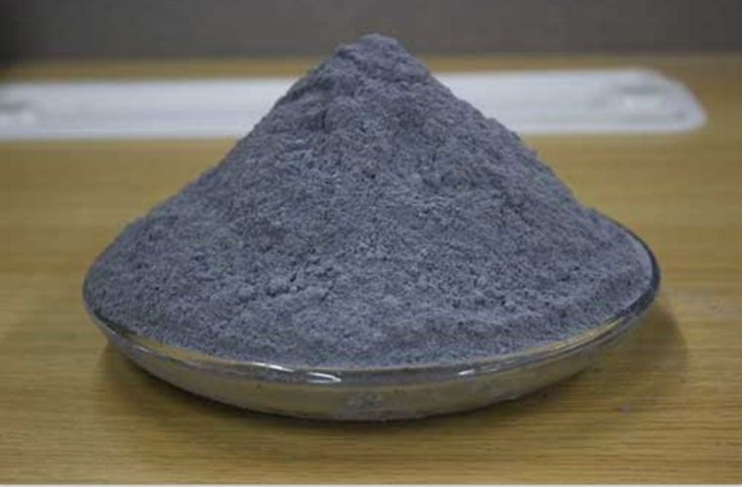
Figure 1: Silica Fume

Table 1: Properties of Silica Fumes

Components of Cement: Comparison of Chemical and Physical Characteristics
Property |  | Portland cement | Siliceous [b] fly ash | Calcareous[c] fly ash | Slag cement | Silica fume
Content (%) | SiO₂ | 21.9 | 52 | 35 | 35 | 85–97
 | Al₂O₃ | 6.9 | 23 | 18 | 12 | —
 | Fe₂O₃ | 3 | 11 | 6 | 1 | —
 | CaO | 63 | 5 | 21 | 40 | < 1
 | MgO | 2.5 | — | — | — | —
 | SO₃ | 1.7 | — | — | — | —
Specific surface[d] (m2/kg) |  | 370 | 420 | 420 | 400 | 15,000–30,000
Specific gravity |  | 3.15 | 2.38 | 2.65 | 2.94 | 2.22
General use in concrete |  | Primary binder | Cement replacement | Cement replacement | Cement replacement | Property enhancer

  - Super plasticizer

An industrially available remarkable plasticizer (SP) specially CONSFLO HP putting forward to ASTM C 494 type G and F and IS 9103:1999 have become enforced inside aspect the route of the exam for enterprise enough usefulness. CONSFLO HP can be a chloride unfastened undue get water amendment plasticizer (HRWR) seeable of decided on polycarboxlate compound provided with as a small earthy colored fluid. CONSFLO HP is a ground-breaking plasticizer, that scatter and deflocculates the concrete debris in the robust blend. CONSFLO HP are regularly carried out to no inheritable thick, strong and excessive intense electricity concrete. CONSFLO HP improves functionality, even as now no longer the growth of greater water, or to permit decreases in unfastened water content material cloth artefact as AN lousy ton as 40%, on the ones strains turns on easy state of affairs and completing of cement even as now no longer the opportunity of isolation and dying. the houses of remarkable plasticizer are appeared.

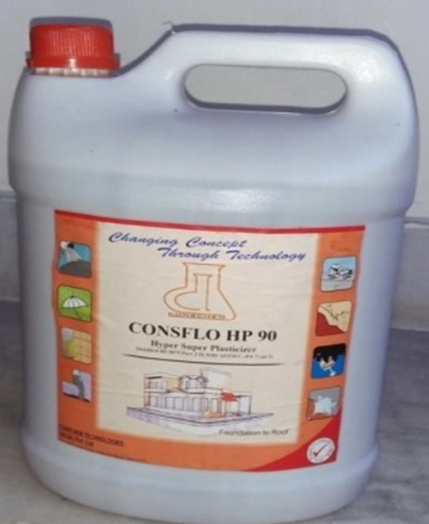
Figure 2: Super plasticizer

Table 2: Properties of Super plasticizer
S. No. | Characteristics | Description
1. | Specific gravity | 1.105
2. | pH | 4-7
3. | Chloride content | Nil

Method

Target mean strength for mix design (Grade M40) f’ck= fck+1.65s

where,
f’ck= Target mean compressive strength at 28 days in N/mm²

fck= Characteristic compressive strength at 28 days in N/mm²s = Standard deviation N/mm²

From IS: 10262 - 2017 (Draft code), s = 5 N/mm²
Target mean strength = 40 + 1.65 x 5 = 48.25 N/mm².

Entrapped air

Approximate amount of entrapped air to be expected in normal (non-air entrained) concrete is 1.0 % for 20 mm nominal maximum size of concrete.

Selection of Water Cement ratio

From IS: 456 - 2000, w/c ratio for severe condition = 0.45
The water cement ratio required for the target strength of 53.25 N/mm² is 0.33 for maximum size of aggregate i.e. 20 mm.
  - 0.45, hence OK

Selection of water content

Maximum water content for 20 mm aggregate = 186 liter (For 50 mm slump without super plasticizer).

Estimated water content for 120 mm slump
= 186 + (8.4 / 100) x 186 (CL 5.3; 3 % increase for every 25 mm increase in slump). = 202 liter

As super plasticizer is used, the water content may be reduced up to 25% (Annexure F). Hence the reduced water content = 202 x 0.75 = 151litre.

Calculation of Cement & Micro silica content

Water-cement ratio = 0.40
Cement content = 151 / 0.40
= 368.29 Kg/m³ or 370 kg/m³

From IS: 456 - 2000, minimum cement content for severe exposure condition = 320 Kg/m³.

370 Kg/m³ > 320 Kg/m³, hence OK Check for maximum cement (OPC) content

370 kg/m³ < 450 kg/m³, hence OK
In order to study the influence of micro Silica on the mix design, let us reduce the quantity of cement by say 3 %.

Quantity of cement replaced by micro Silica = 370 x 0.03
= 11.10 Kg/m³ ≈ 11.00 Kg/m.

Total Cementitious content for the mix, i.e. Quantity of cement (359 Kg/m³) + Quantity of micro Silica (11) Kg/m³, with a water-cementitious ratio equal to 0.40.

Proportion of volume of coarse aggregate and fine aggregate

Extent of coarse combination corresponding to twenty mm
length combination and satisfactory combination (Zone II) for w/c ratio 0.50 =0.62.
In the prevailing case water cement ratio is 0.40. Therefore, extent of coarse combination is needed to be elevated to lower the satisfactory combination content. As the water-cement ratio is decrease through 0.17, the percentage of extent of coarse combination is elevated through.
0.034 (at the rate of -/+ 0.01 for every +/- 0.05 change in w/c ratio)

Corrected proportion of vol. of course aggregate for the water cement ratio of 0.33.

= 0.62 + 0.034 = 0.654 per unit volume of total aggregate

For pump able concrete, this value may be reduced by about 10 % (CL 5.5.1). Considering 10 % reduction.

Volume of coarse aggregate = 0.654 x 0.90 = 0.59 per unit volume of total aggregate & Volume of fine aggregate = 1.0 - 0.59 = 0.41 per unit volume of total aggregate

Mix Calculation

Volume of concrete = 1 m³

Volume of entrapped air in wet concrete = 0.01m³

Volume of cement = (Mass of cement / Specific gravity of cement) x ((1 /1000) = (359 / 3.15) x (1 / 1000) = 0.113 m³

Vol. of Micro silica = (Mass of Micro silica/ S.G Micro silica) x (1/1000) = (11 / 2.20) x (1 / 1000) = 0.0050 m³

Volume of water = (Mass of water / Specific gravity of water) x (1 /1000) = (151/1.00) x (1/1000) = 0.151 m³
Volume of superplasticizer (@ 1 % by mass of cementitious material) = (Mass of superplasticizer / Specific gravity of superplasticizer) x (1 /1000) = (4.28 / 1.105) x (1 / 1000) = 0.0039 m³

Volume of all in aggregate = [(a – b) – (c + d + e +f)]

= [(1 - 0.01) - (0.113 + 0.0050 + 0.151 + 0.0039)]
= 0.7171 m³

Mass of coarse aggregate = g x volume of coarse aggregate x specific gravity of coarse aggregate x1000
= 0.7171 x 0.59 x 2.68 x 1000 = 1133 kg

Mass of fine aggregate = g x volume of fine aggregate x specific gravity of fine aggregate x1000 = 0.7171 x 0.41 x 2.65 x 1000 = 779 kg

Mix proportion for Trial 1, Cement = 359 kg/m³
Micro silica = 11kg/m³
Water = 151 kg/m³
Fine aggregate = 779 kg/m³ Coarse aggregate = 1134 kg/m³ Super plasticizer = 4.28 kg/m³ W/C ratio = 0.40

Table 3: Final Mix Proportions
Cement + Micro  Silica, % (kg/m³) | Fine aggregate  (kg/m³) | Coarse aggregate  (kg/m³) | Water  (kg/m³)
359 + 11 | 779 | 1133 | 151
1.00 | 2.105 | 3.062 | 0.40
 | or 1.00 : 2.10 : 3.00 : 0.40

Similarly, technique have become observed for blend format of controlled specimen (i.e. at the same time as now no longer small silicon oxide) and varied} take a look at specimen with diverse prospects (zero % to twenty %) of micro silica. Below is that the desk showing one of a kind combo share incorporating precise opportunities of micro silica observed inside facet the study.

  - Specimens

Three styles of specimens are cast: a hundred fifty x a hundred fifty x a hundred fifty millimeter cubes, a hundred fifty x three hundred mm cylinders, and a hundred x a hundred x 5 hundred mm prismatic beams. The issue of the specimens solid for the duration of the whole experimental package deal is summarized in Table 5.

Table 4: Concrete Mix Proportions
Mix (% micro silica) | Mix Proportions |  |  |  |  |  | W/C ratio
 | Cement (kg/m³) | Fine aggregate (kg/m³) | Coarse aggregate (kg/m³) | Micro silica  (kg/m³) | Water (liter) | Super plasticizer  (liter)
0.0 % | 370.0 | 775 | 1133 | 0.00 | 151 | 4.28 | 0.40
5% | 351.5 | 759.5 | 1104.5 | 18.50 | 151 | 4.28 | 0.40
10 % | 333.0 | 742 | 1076.5 | 37.0 | 151 | 4.28 | 0.40
15 % | 314.5 | 720.5 | 1048 | 55.5 | 151 | 4.28 | 0.40
20 % | 296.0 | 701 | 1020 | 74.0 | 151 | 4.28 | 0.40

Table 5: Detail of Specimens
Mix (% micro silica) | No. of Specimen |  | Total No. of Specimen
 | Cubes (Compressive  Strength) |  | Cylinders (Split Tensile  Strength) | Beams (Flexural  Strength)
 | Days 7 | Days 28 | Days 28 | Days 28
0.0 % | 3 | 3 | 3 | 3 | 60
0.5 % | 3 | 3 | 3 | 3
1.0 % | 3 | 3 | 3 | 3
1.5 % | 3 | 3 | 3 | 3
2.0 % | 3 | 3 | 3 | 3
Total | 15 | 15 | 15 | 15

Table 6: Compressive strength of concrete with cement replaced by micro silica
Mix (% micro silica) | Water Cementitious Ratio | % of Superplasticizer  (% by weight of cementitious material) | Age (Days) | Average  Compressive Strength (MPa) | n % Variation
0.0 % | 0.40 | 1.0 | 7 | 31.55 | 0.00
 |  |  | 28 | 47.80 | 0.00
05 % | 0.40 | 1.0 | 7 | 34.78 | 10.23
 |  |  | 28 | 51.27 | 7.05
10 % | 0.40 | 1.0 | 7 | 38.20 | 21.07
 |  |  | 28 | 55.98 | 17.11
15 % | 0.40 | 1.0 | 7 | 42.45 | 34.54
 |  |  | 28 | 58.02 | 21.38
20 % | 0.40 | 1.0 | 7 | 41.40 | 31.22
 |  |  | 28 | 56.23 | 17.63

- Results and discussions

The cement changed into changed via way of means of micro silica in various dose of 05%, 10%, 15%, and 20%. Concrete dice specimen of length 150× 150 × 150 mm in blend share of 1:2.10:3.00 had been solid with water cement ratio as 0.40 and compressive power changed into ascertained after 7 days and 28 days of curing. Total no. of blend accordingly fashioned changed into five and no. of dice solid is 30.
Fig. 3 and table 6 reveals that compressive power of concrete increase as much as 15% alternative of cement with the aid of using micro silica. However, the concrete compressive power decreases while the cement is changed with the aid of using micro silica past 15%.
With 5% of cement being changed through small oxide, the concrete compressive electricity can boom thru 10.23% associated seven.25% at 7 and twenty-eight days severally with appreciate to govern specimen at 7 and 28 days respectively. The compressive electricity of concrete with 10% cement modified thru micro silica imparts an boom within side the electricity thru 21.05% and 17.11% at 7 and 28 days respectively with appreciate to manipulate specimen at 7 and 28 days respectively. With 15% of cement being modified thru micro silica, the concrete compressive electricity will boom thru 34.55% and 21.38% at 7 and 28 days respectively with appreciate to govern specimen at seven and twenty-eight days respectively.
The compressive energy of concrete with 20% cement changed via way of means of micro silica imparts a boom within side the energy via way of means of 31.22% and 17.63% at 7 and 28 days respectively with appreciate to govern specimen at 7 and 28 days respectively. The cement became modified with the help of victimization small silicon dioxide in varied dose of 05%, 10%, 15% and 20%. Concrete cylinder specimen of length 1 50 x 300 millimeter in mix share of 1:2.10:3.00 are solid with water cement quantitative relation as 0.40 and cut up tensile power became observed when seven days and twenty-eight days of curing. Total no. of blend consequently formed became 5 and no. of cylinder solid became 15.

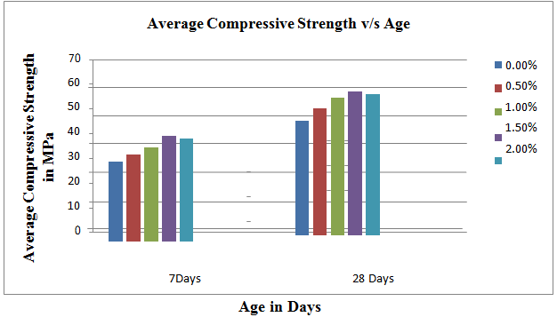
Figure 3: Average Compressive strength of concrete with Cement replaced by micro silica at 7 and 28 days

Fig. 5 and Table 7 it's far obtrusive that cut up tensile energy of concrete will increase as much as 15% alternative of cement with the aid of using micro silica. However, the cut up tensile energy of concrete decreases whilst the cement is changed with the aid of using micro silica past 15%.
With 05% of cement being changed through micro silica, the concrete cut up tensile energy additionally will increase through 3.43% at 28 days with admire to govern specimen at 28 days respectively.

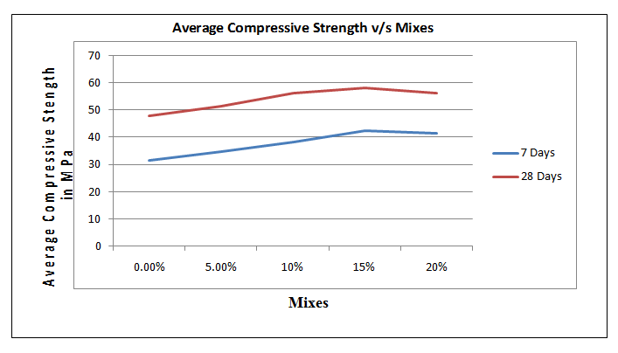
Figure 4: Average compressive strength of concrete v/s Mixes at 7 and 28 days

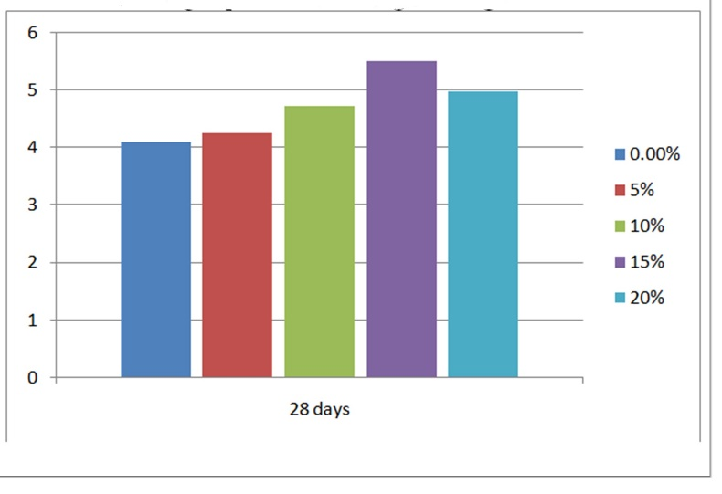
Figure 5: Average split tensile strength v/s age

The cut up tensile energy of concrete with 10% cement changed through micro silica imparts a boom within side the energy through 11.37% at 28 days with admire to govern specimen at 28 days respectively. With 15% of cement being changed through micro silica, the concrete cut up tensile energy will increase through 16.43% at 28 days with admire to govern specimen at 28 days respectively.
A considerable extrude within side the energy sample is discovered whilst the cement is changed through micro silica past 15%. The break up tensile energy of concrete with 20% cement changed through micro silica indicates a discount within side the energy through 9.38 % at 28 days with recognize to manipulate specimen at 28 days respectively. The cement became changed through micro silica in various dose of 05%, 10%, 15% and 2.0%. Concrete beam specimen of length 100x100x500 mm in blend share of 1:2.10:3.00 have been forged with water cement ratio as 0.40 and flexural energy became ascertained after 7 days and 28 days of curing. Total no. of blend for that reason fashioned is 05 and no. of beam forged is 15. Fig. 6 and Table 8 it's miles obvious that flexural energy of concrete will increase as much as 15% substitute of cement through micro silica. However, the flexural energy of concrete decreases while the cement is changed through micro silica past 15%.
With 5% of cement being changed via way of means of micro silica, the concrete flexural power will increase via way of means of 16.8% at 28 days respectively with recognize to govern specimen at 28 days, respectively. The flexural power of concrete with 10% cement changed via way of means of micro silica imparts a boom within side the power via way of means of 18.4% at 28 days respectively with recognize to govern specimen at 28 days respectively. With 15% of cement being changed via way of means of micro silica, the concrete flexural power will increase via way of means of 21.62% at 28 days respectively with recognize to govern specimen at 28 days respectively

Table 7: Split Tensile Strength of concrete with Cement replaced by Micro Silica

Mix (% Micro silica) | Water cementations ratio | % of Super plasticizer (% by weight of cementations material) | Age (Days) | Average Failure Load (KN) | Average Split Tensile Strength (MPa) | %  Variation
0.0 % | 0.40 | 1 | 28 | 250 | 4.105 | 0
05 % | 0.40 | 1 | 28 | 260 | 4.246 | +3.43
10 % | 0.40 | 1 | 28 | 280 | 4.729 | +11.37
15 % | 0.40 | 1 | 28 | 290 | 5.506 | +16.43
20 % | 0.40 | 1 | 28 | 300 | 4.989 | -9.38

Table 8: Flexural Strength of concrete with Cement replaced by micro Silica
Mix (% micro silica) | Water Cementations Ratio | % of Super plasticizer (% by weight of cementations material) | Age (Days) | Average Failure Load (KN) | Average Flexural Strength (MPa) | %  Variation
0.0 % | 0.40 | 1 | 28 | 10.7 | 5.500 | 0
05 % | 0.40 | 1 | 28 | 12.5 | 6.750 | +16.8
10 % | 0.40 | 1 | 28 | 14.8 | 7.250 | +18.4
15 % | 0.40 | 1 | 28 | 18.0 | 8.000 | +21.62
20 % | 0.40 | 1 | 28 | 10.5 | 5.600 | -41.6

A considerable extrude within side the energy sample is discovered whilst the cement is changed through micro silica past 15%. The break up tensile energy of concrete with 20% cement changed through micro silica indicates a discount within side the energy through 9.38 % at 28 days with recognize to manipulate specimen at 28 days respectively.
The cement became changed through micro silica in various dose of 05%, 10%, 15% and 2.0%. Concrete beam specimen of length 100x100x500 mm in blend share of 1:2.10:3.00 have been forged with water cement ratio as 0.40 and flexural energy became ascertained after 7 days and 28 days of curing. Total no. of blend for that reason fashioned is 05 and no. of beam forged is 15.
.
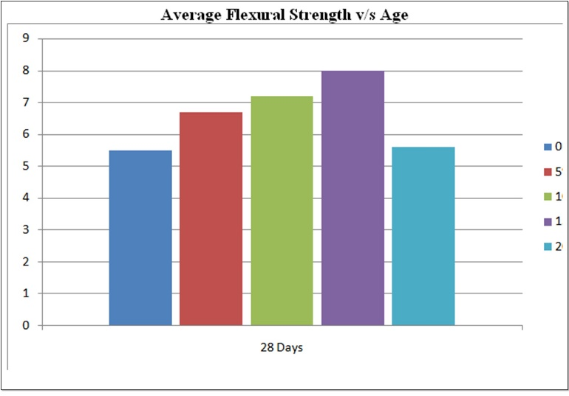
Figure 6: Average flexural strength v/s Age

A sizeable extrude within side the power sample is determined while the cement is changed via way of means of micro silica past 15%. The flexural power of concrete with 20% cement changed via way of means of micro silica suggests a discount within side the power via way of means of -41% at 28 days respectively with recognize to govern specimen at 28 days respectively.

Conclusions

On the premise of experimental results, the subsequent conclusions were drawn.
  - There is a usual growth in mechanical residences of the concrete with the creation of micro silica appreciably.
  - For the concrete mixes with cement being changed through micro silica, the power will increase with growth in micro silica content material as much as 15% substitute of cement through micro silica.
  - The most percent growth in power is located as 34.54 % for blend where in 15 cement is changed with micro silica and examined after 7 days of curing.
  - The percent growth in 28 days’ power is mentioned as 7.25%, 17.11%, and 21.38percentformix i.e. 05%, 10%, 15% and 20% micro silica respectively.
  - With the addition of micro silica, the enhancing percent of splitting tensile power of concrete reaches approximate charge of approximately 78% respectively, with appreciate to the manage mix.
  - With the addition of micro silica, the enhancing percent of flexural power of concrete reaches approximate fee of approximately 69% respectively, with recognize to the manage blend.
  - The stepped forward compressive power might be attributed to the reduced loose w/cm ratio with surest doze of High variety water decreasing admixture (Polycarboxylate ether primarily based totally outstanding plasticizer), higher compaction and interlocking of debris of various sizes within side the concrete composite.
  - To enhance the workability of the concrete mixes, the usage of High variety water decreasing admixture (Polycarboxylate ether primarily based totally outstanding plasticizer) was necessary.
  - Bending pressure turned into determined to boom with the boom in percent of micro silica as much as 15% micro silica and past it the cost reduced.

References

- Mahdikhani, M., Bamshad, O., Shirvani, M.F., (2018) Mechanical properties and durability of concrete specimens containing nano silica in sulphuric acid rain condition, Journal of Construction and Building Materials 167, 929-935 (Elsevier Publication).
- Wang, X.F., Huang, Y.J., Wu, G.Y., Fang, C., Li, D.W., Han, N.X., Xing F. (2018) Effect of nano-SiO2 on strength, shrinkage and cracking sensitivity of lightweight aggregate concrete, Construction and Building Materials 175, 115-125 (ElsevierPublication).
- Ghazy, A., Bassuoni, M. T. (2017) Shrinkage of Nanomodified Fly Ash Concrete as Repair Material, Journal of Materials 114(6), 877-888 (ACIPublication).
- Lim, S., Monda, P. (2015) Effect of Nanosilica addition on increased thermal stability of cement-based composite, Journal of Materials 112(2), 305-316 (ACI Publication).
- Bolhassani, M., Samani, M. (2015) Effect of Type, Size, and Dosage of Nanosilica and Microsilica on Properties of Cement Paste and Mortar, Journal of Materials 112(2), 259-266 (ACIPublication).
- Amin, M., Abu-el-hassan, K.(2015) Effect of using different types of nano materials on mechanical properties of high strength concrete, Journal of Construction and Building Materials 80, 116-124 (ElsevierPublication).
- Mukharjee and Barai, (2014) Influence of nano silica on the properties of recycled aggregate concrete, Journal of Construction and Building Materials 55, 29-37 (ElsevierPublication).
- Ibrahim, R.K., Hamid, R., Taha, M.R.(2014) Strength and microstructure of mortar containing nanosilica at high temperature, Journal of Materials 111(2), 163-170 (ACIPublication).
- Byung-Wan, J., Kim, C.H. Lim, J.H., (2007) Characteristics of Cement Mortar with Nano-SiO2 Particles, Journal of Materials 104(4), 404-407 (ACIPublication).
- Ghafoori, N., Iani B., Meysam N., (2016) Sulfate Resistance of Nanosilica and Microsilica Contained Mortars, Journal of Materials, 113(4), 459-469 (ACI Publication).
- Sikora, P., Łukowski, P., Cendrowski, K., Horszczaruk, E., Mijowska. E., (2015) The effect of nanosilica on the mechanical properties of polymer-cement composites (PCC), Procedia Engineering 108, 139 – 145. (ElsevierPublication)
- Bastami, M., Baghbadrani, M., Aslani, F., (2014) Performance of nano-Silica modified high strength concrete at elevated temperatures, Journal of Construction and Building Materials 68, 402-408 (ElsevierPublication).
- Shah, M.M.A, Balaji, E., Pandian, G.A.M. (2016) Experimental study of mechanical properties of high strength concrete using Nano-Silica, Journal of Construction and Building Materials 3, 143-151(ElsevierPublication).
- Thasleem P., Naveen K., (2016) A study on strength properties of concrete containing micro-silica and nano-silica, International Research Journal of Engineering and Technology 5,56-61.
- Walzade, S.B., Tarannum, N., (2016) Influence of Colliodal Nano- SiO2 on durability properties of high strength concrete, Journal of Construction and Building Materials 3, 82-90 (Elsevier Publication).
- Rahim, A., Nair S.R., (2016) Influence of Nano-Materials in High Strength Concrete, Journal of Chemical and Pharmaceutical Sciences 10,15-22.
- Zhang M.H., Islam, J., (2012) Use of nano-silica to reduce setting time and increase early strength of concretes with high volumes of fly ash or slag, Journal of Construction and Building Materials 29, 573–580 (Elsevier Publication).
- Abd El Hameed, M.F., Ghazy, M.F., AbdElaty, M.A., (2016) Cement mortar with nano silica: Experiments with mixture design method, Journal of Materials, 113(1), 45-53 (ACIPublication).
- Guefrech, M.L.A., Mounanga, P., Khelidj, A., (2011) Experimental study of the effect of addition of nano-silica on the behaviour of cement mortars, Procedia Engineering, 10, 900–905 (ElsevierPublication).
- Heikal, M., Abd El Aleem, S., Morsi, W.M., (2013) Characteristics of blended cements containing nano-silica, Journal of Housing and Building National Research Centre, 9, 243–255.
- Belkowitz, J., Whitney S., Le, B., Nawrocki, B.K., Fisher, F.T. (2015) The impact of Nano silica size and surface areas on concrete properties, Journal of Materials 112(3), 419-428 (ACIPublication)

Cite this article as: Syed Azeem Husain, Rajkiran Singh. Mohd. Moonis Zaheer, Concrete mix design with micro silica and its influence on mechanical properties of concrete, International journal of research in engineering and innovation (IJREI), vol 5, issue 5 (2021), 250-257. https://doi.org/10.36037/IJREI.2021.5505

